5. Modulation of autoISF aggressiveness. V 2.62next

Please note that with autoISF 3.0 you are in an early-dev. environment, where the user interface is not optimized for safety of users who stray away from intended ways to use. Good safety features exist, but these are only as good as the development-oriented user understands and implements them. This is not a medical product, refer to disclaimer in section 0

5.1 Automatic modulation of loop aggressiveness
Available (related) case studies:

Case study 5.2: Sweet snack. juice snacks ……/ or Glühwein (5.2.2.3)

5.1.1 “autoISF off” outside of meal times
5.1.2 SMB off @ odd profile target
5.1.3 SMB off @ odd temp. target
5.1.4 diff. of FCL aggressiveness via Automations
5.1.5 diff. of FCL aggressiveness via Activity Monitor
5.1.6 Pro/con completely hands-off FCL
5.2 Manual modulation of FCL aggressiveness (DIY cockpit)
5.2.1 Status recognition
5.2.2 Manual interventions from DIY cockpit
5.2.2.1 Temp. %profile or TT settings
5.2.2.2 Temp. settings in /preferences
5.2.2.3 Grey DIY cockpit buttons for FCL responses
5.2.3 Temporary exit from FCL
5.3 Manual modulation via improved cockpit
5.3.1 Violet FCL icon and underlying buttons
5.3.2 Bottom buttons “insulin” etc.
5.3.3 Top three fields
5.3.3.1 TT dialogue field
5.3.3.2 Exercise button / dialogue field
5.3.3.3 Profile dialogue field
5.4 Recognizing loop state from the AAPS home screen
5.4.1 Color scheme (grey/yellow) of the top 3 fields
5.4.2 Info on the top 3 fields (profile, exercise, TT)
5.4.3 FCL related indicator fields
5.4.4 Overall AAPS home screen

Once the initial tuning according to section 4. is done, you are ready to use autoISF for your fully automated meal management.

You will have three major other challenges to manage:
- recognize and manage (partial) occlusions, or other technical (CGM or BT related) obstacles (see section 1 on pre-requisites of FCL, and related case studies)
- deal with times when insulin given by the loop must be restricted (e.g. a snack could be “misinterpreted” as a meal)
- deal with times when the loop should be set "milder" as a precaution (e.g. nights; or in an exercise context).
How big the remaining challenge is depends very much on your individual lifestyle. Sections 5 and 6 discuss this in more detail.
In order to run the loop fully automatically around the clock, the times outside the meal blocks must also be precisely analyzed, and solutions to problems (if any) must be sought.

It is up to every user to decide where to draw the line.
- With a technically well functioning system, moderate meals, moderate or no exercise, moderate %TIR expectations and a bit of mindfulness it should be possible to go into Full Closed Loop 24/7, after working through, and observing, sections 1-4.
- Especially if you are a bit shy of using the emulator for really detailed analysis, it is likely that you will not hit one real good system calibration (section 4) for your entire range of diets.
In that case you will occasionally run out of range, and your options to prevent, react, or improve are
  - accepting a few % higher time outside range for that day (and, if feasible, in the future avoiding what seemed to have caused it)
  - taking a snack (whenever you tend to go low from the “tails” of insulin activity that was required to fight a peak)
  - doing a manual override (if you can think of one in time, to manage the problem manually)
  - temporarily resorting to the well-known hybrid closed loop.

Instead of accepting such instances, you could launch “improvement projects”
- that refine your initial tuning (section 4. and sections 8-9)
- that make you and your FCL loop fit to manage an increasing number of disturbances either automatically, or via an “informed”, maybe pre-programmed, user intervention (notably, an exercise “announcement”) (sections 5-6).

To tailor the loop’s response to disturbances other-than your major meals probably will require specific modulation of the aggressiveness that you set according to section 4 for your meal management.

There are many avenues to achieve this. The main ones, that are also easy accessible via Automations in AAPS, are:

- temporary shut-off SMBs (odd-numbered target)
- temporary reduce bgAccel_ISF-weight
- temporary reduce iobTH_percent
- temporary reduce set %profile
- temporary set higher TT (especially in connection with exercise mode)t

After set up of your core FCL for fully automatic meal management according to section 4, and some performance monitoring (section 8) and trouble shooting (section 9) you probably will identify areas that you like to further improve (notably to cut down the occasional need for snacks in an exercise context).

In setting up your FCL, you then have another difficult and time-consuming job at hand, to define solutions for any of your „other“ situations (outside of meal management) that tend to drive glucose outside of the desirable range.

- In section 5.1 we explore avenues towards fully automated management that in daily life will require no user intervention at all.
- In section 5.2 and 5.3 we will look at solutions that involve an easy user interaction like a data entry or button push.

5.1 Fully automatic modulation of FCL aggressiveness

The following subchapters describe set-ups you may want to use for allowing completely hands-off FCL in as many daily situations as possible.

5.1.1 autoISF ISF adaptations generally switched off outside of meal-time windows

If, aside from having to bolus for meals, your hybrid closed loop was running pretty well without other interventions from your side, you could continue to run in that mode, and just focus your new autoISF FCL on management of meals.

In your initial transitioning phase this approach makes a lot of sense, and even by focusing autoISF on just a sub-set of them, like only dinners.

Also in the long run this avenue is taken by many FCL users for the night times, “hanging on” to their well performing hybrid closed loop with standard oref(1) SMB+UAM

For this, you define Automations

- that set meal time windows in which “Enable ISF adaptation by glucose behavior” (autoISF) is turned on in AAPS preferences/OpenAPS SMB
- or: that turn all autoISF’s ISF modulations (or just bgAccel_lSF ) off in time windows in which surely no meal occurs. For instance, you can go for all nights back into your Hybrid Closed Loop, as you had before.

Other early DEV AAPS variants (see section 13.3) all work with meal-time windows. The window is either set by time of day in the settings, or it always must be „set“ by the user via giving a mandatory small pre-bolus before any meal starts. Outside of these time windows, these loops then runs with less aggressive SMBs like oref(1) SMB+UAM in AAPS Master.
This mode is not really FCL, but an advance over traditional HCL that often achieves satisfying degrees of automation and performance.
The term Meal Announcement (MA) is often used to label this closed looping mode. Trigger to set a meal time window could also be a pre-bolus given by the user, a carb entry made, an EatingSoonTT set, or a meal announcement button pushed.

Note: Outside of the meal time windows you would be in hybrid closed loop. To the extent you rarely face disturbances (aside from meals), you could be looping in full automatic mode around the clock,

Your temp. “autoISF shut-down” (exiting autoISF FCL = shutting off “Enable ISF adaptation by glucose behaviour“) is meant to prevent problems from the loop over-reacting to bumps in the glucose curve in times of day (night) when standard oref(1) performance is sufficient.

A very good alternative to fully resorting to Hybrid Closed Loop is “taming” the FCL via a night time SMB shut-off (see next section 5.1.2).

5.1.2 Odd-numbered profile targets used to block SMBs

An alternative route of preventing the FCL loop from over-reacting to bumps in the glucose curve would be to make use of the option to temporarily shut down SMBs

Ensure the even/odd logic in the settings is toggled on in Preferences> openAPS SMB> autoISF settings> smb delivery settings>: "Enable alternative activation of SMB depending on profile target" ON.

In time blocks with an odd-numbered profile target you can prevent any SMBs being given by your loop. The (unchanged) aggressive settings then can only translate within the limits set by %TBR possible.

This will very much slow down any more insulin being given, and is an excellent solution for night times, especially if you occasionally experience compression lows.

Alternatively, you could use the new included options for Automation Conditions and temporarily tune your bgAccel_ISF_weight much lower (section 5.1.4).

Yet another alternative was already presented (section 5.1.1) = to go into hybrid closed loop for the night.
That is possible to do with SMBs available (without them getting boosted via autoISF), and, for a long time, was the author’s favoured solution for the nights.

But, my current favorite builds on the method of this section (5.1.2, odd profile target provides SMB shut off), but then allowing some, automatically triggered when needed:

In case you occasionally do have nights that would benefit from a couple of SMBs (to treat temp. highs from a late fatty pizza, raclette and such): Define suitable Automations like the two „night“ ones in this example:
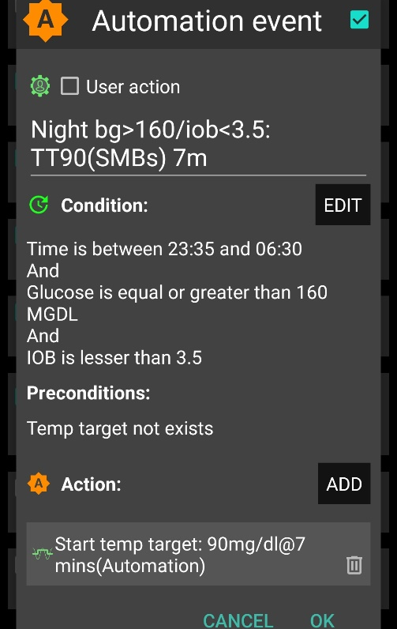
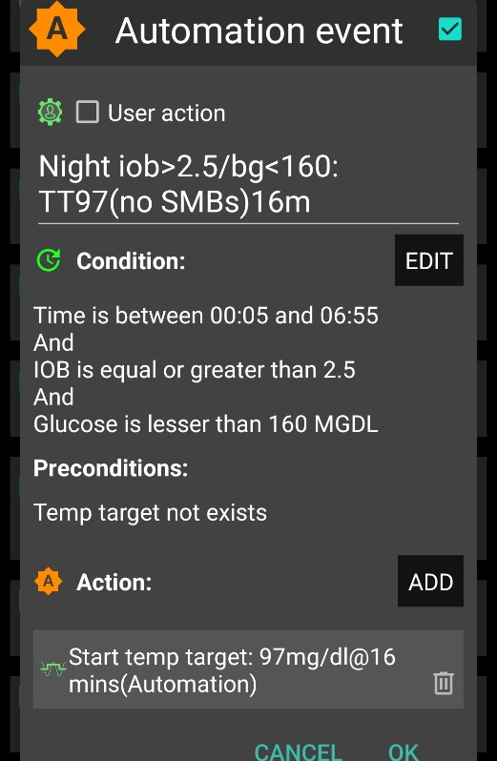

Never underestimate the „trickyness“ of getting your Automations „right“.
With your thought-out Automations in place, night data need to be analyzed to see
- whether the bg and iob limits defined in the given example work sensibly four your data pattern
- whether the TT duration is chosen appropriately
- how swapping the sequence in which the automations appear in the Automation list would lead to different SMB impacts.

5.1.3 Odd-numbered temp. targets (TT) set via Automation used to block SMBs

A widely used Action that strongly modifies how fast your FCL can add more iob is setting an odd-numbered temp. glucose target which makes the loop operate without giving any SMBs (%TBR modulation only).
Ensure the even/odd logic in the settings is toggled on in Preferences> openAPS SMB> autoISF settings> smb delivery settings>: "Enable alternative activation of SMB depending on TempTarget" ON.

So, from patterns you find in YOUR data, at times where you want your loop act differently, you need to carve out Conditions that describe the respective situations (and either for how long it typically lasts, or at which other Conditions you want your loop get back to default FCL operation).
An odd TT is often set for an anti-hypo snack or sports snack. In both instances, you do not want SMBs to quickly counter act.
In case of sweet “fun” snacks, this is entirely different -> section, 5.2.1 or for regular snacks (e.g.at school break) see next section 5.1.4

5.1.4 Automatic differentiation of FCL aggressiveness using Automations

Personalized Automations tailor the loop exactly to YOUR data so fully automated handling of situations with different aggressiveness of the loop can be made.

From, autoISF 3.0 onwards, also the following parameters are provided as Condition and/or as Action for defining YOUR Automations:
- Enable ISF adaptations by glucose behaviour => Allows temp. ON/OFF for the key ISF modulation parts of autoISF (and, as a result, will usually decrease loop aggressiveness)
- Trigger/set iobTH percent => Keeps default aggressiveness, but only until a iob threshold (that your Automation modifies) is surpassed (which is when any further SMBs will be blocked blocked)
- Trigger/set bgAccel_ISF_weight => Modifies the default aggressiveness of just the acceleration component

To set up suitable Automations, you first must analyze patterns you find in YOUR data, at times (or geo-locationa, or bg and iob patterns that point to a problem …) where you want your loop act differently, to carve out Conditions that describe the respective situations (and either for how long it typically lasts, or at which other Conditions you want your loop get back to default FCL operation).

A variant of this mode is to define several windows in which autoISF aggressiveness (bgAccel_ISF_weight) and/or iobTH are automatically set differently
- for different meal time slots of your day –
(Breakfast at home, school lunches, school intermission snacks, dinners at home could for example all deserve special settings regarding ISF_weights and iobTH).
Note: Circadian differences in insulin sensitivity between meal times are included via your ISF profile and should not be a reason for different _weights needed between meals!
- or even for a geo-location etc –
(School lunches, or mother-in-law visits, would be examples).
An example for this was given in section 3 already:
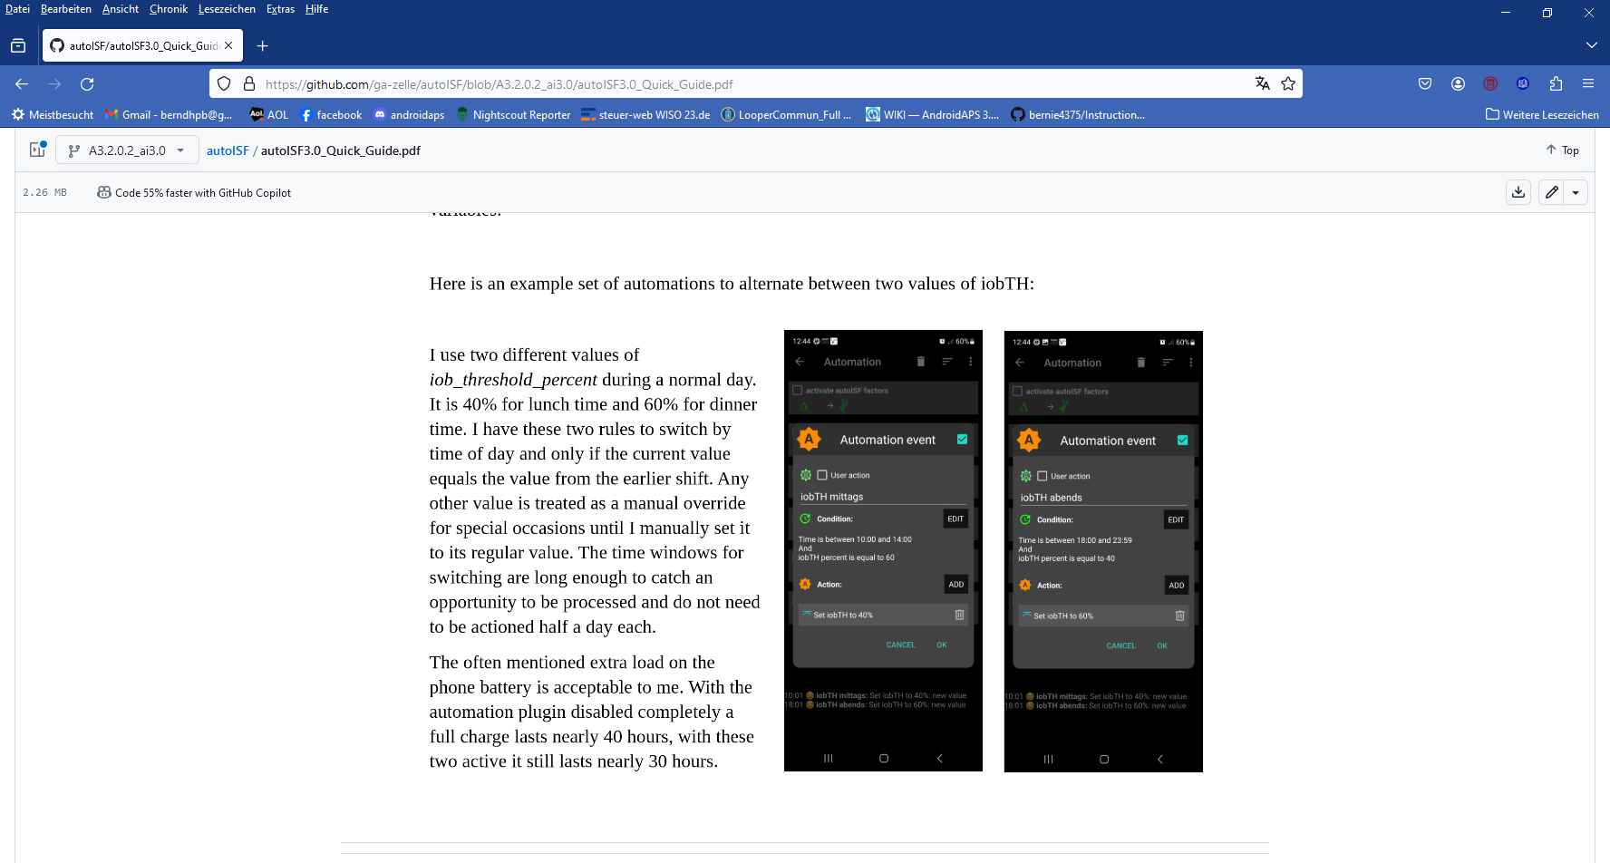
lunch
dinner

Unless your meals differ vastly in size and in fast carb content all this may not be needed.

Still, personalized Automations might help ease your initial job of setting the various ISF_weights, and a best-suitable iob_theshold_percent that would work “always”.

Note: Only the main two parameters (bgAccel_ISF_weight for “initial aggressiveness”, and iobTH_percent for “where SMBs stop”) are available in Automations. So, finding your parameter sets for each of the time slots, will not be trivial. => Spending more effort to set the .._weights so they accommodate just one, broader spectrum (section 4.) should be the first, and standard, approach.
An intermediate (maybe only temporary) approach could be to use a profile switch (for low carb meal, or eating half, setting %profile to 60% for instance, and only for the brief, less than an hour, initial meal period). See section 5.2.2.

Caution: If (as in autoISF 3.0) setting a different iobTH or bgAccel_ISF_weight can not be done temporarily (i.e. with a duration attached) you must define a suitable additional Automation, that
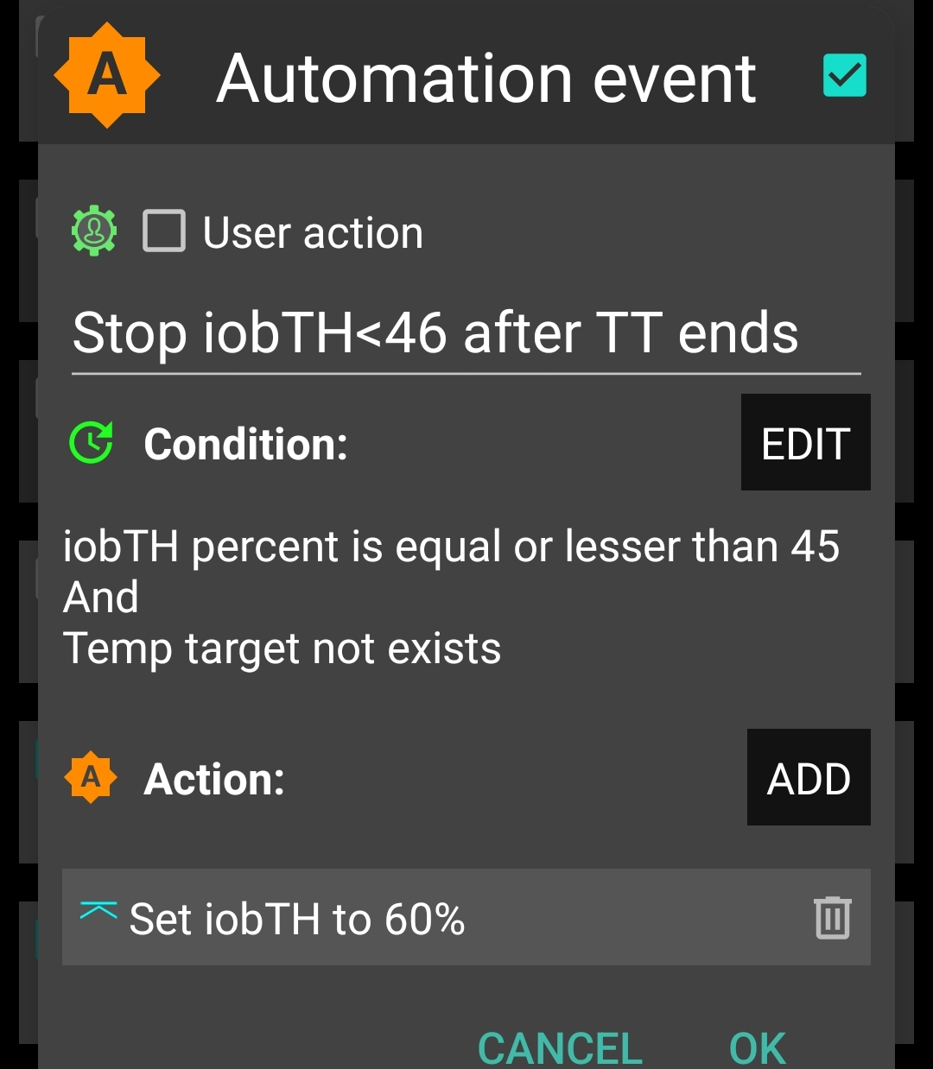
must be active in tandem, that restores the default set iobTH or bgAccel-ISF_weight again. Else, once your Automation set in, it will forever shift this important parameter setting!
If for instance you have several Automations that, in combination with a set elevated TT also set a lower iobTH: Don’t be fooled, the duration only applies to the TT. You need an extra Automation for all of them.
I picked out the highest of the altered iobTH values that these Automations can set (45_percent), and then I can automatically restore my default desired 60% via this one Automation (see screenshot - - > )

5.1.5 Automatic adjustment of FCL aggressiveness via the Activity Monitor

With the autoISF variant of AAPS you can make use of your smartphone‘s stepcounter and use it to fully automatically adjust insulin sensitivity ratio to activity level in the past minutes to one hour time frame.
This feature comes with yet another little tuning opportunity, in which you study your body’s response to light exercise (like walking) or to not moving at all (like desk, couch), and select appropriate settings which, in the future, will automatically adjust insulin delivery to suit activity state of the past minutes (up to 1 hour).(AAPS Preferences/OpenAPS SMB/Activity modifies sensitivity/ -> set two scaling factors.)

This autoISF feature (new since V.3.0) is much quicker responding than Autosens or dynamicISF to adjust insulin sensitivity to your current „lifestyle state“.

For loopers who do not have huge variations in exercise levels in their everyday lives, this feature might fairly much close the gap towards being able to do a 24/7 hands-off FCL.

Sections 3.5 and 6.5 describe the Activity monitor in more detail.

5.1.6 Pro/con completely hands-off Full Closed Loop

To stay 24/7 in a completely „hands-off“ FCL can be a realistic goal with autoISF 3.0 if besides meals also some special challenges, as discussed in this section 5.1, were analyzed and could be addressed.

Clearly it depends very much on your lifestyle, and how interested, willing, and capable you are to recognize, deal with, (and in the future avoid?) situations that get you outside of your desired %TIR on occasion.
So, this is also about what %TIR you are aiming at, and can accept, as it averages out for the week, for instance.

Everybody must weigh for her/himself
- how much upfront effort to put into the setting up process for getting it all 100% automatic
- or whether to take an easier start, with a couple of situations left to take care of when and as they arise in daily life

Also, even if a principal capability for a fully automatic running FCL is given, this still
means that
- the user should be knowledgeable about what exactly is going on, and
- have a principal capability to „nudge“, or to take over in a manual mode.

In the sections that immediately follow, we present the options to nudge or temporarily take over from the AAPS home screen which will be serving as your FCL cockpit:
- Section 5.2 describes how you can use available “buttons” from your AAPS home screen, and how to complete it towards a suitable DIY FCL cockpit, for an even better FCL experience.
- Section 5.3 describes how you might be able to manage “disturbances” even better (with more convenience) with an improved FCL cockpit in the future. (No need to read any of the green lines, unless you are interested in contributing to define/design/program further improvements)

5.2 Modulating aggressiveness manually, from the DIY-FCL-Cockpit*

* Like in the airplane cockpit: Cruising in full auto mode should involve having an eye on the instruments, and on potential disturbances ahead in the environment.

In section 4. we dealt with major meals. In section 5.1 we looked into fully automatable management of other situations. Life in Full Closed Loop can become extremely easy then…

However: Other disturbances might come up, that:
- are not noticeable in-time, or foreseeable, by the loop (e.g. your plan to start exercise in an hour or two), but that influence sensitivity dramatically and therefore require temporary non-default settings in order to remain in-range, and/or
- require a different “starting point” regarding iob and bg, which translates into a different iobTH that should temporarily be set much lower (in case of exercise) or noticeably higher (e.g. with very fast absorbing carbs in a sweet snack “sin”) .

In section 5.1 we looked into ways to automate also a modified loop response to foreseeable situations (tied to a time of day, geo-location etc), or to those the loop could recognize (with enough time to react).

Other „disturbances“ might come up, and you must find an easy way to
- call up a pre-programmed routine for automatic management, with adjusted aggressiveness, or:
- manually tweak a setting or two, to temporarily adjust the aggressiveness
- There may also arise a desire to just exit the FCL mode, and be your own captain for mastering a special situation.
For peace of mind, to learn, and to stay informed (especially so in your initial tuning phase, or when your glucose curve goes in unexpected ways) we also must be able to
- find the key parameters that frame and drive the recent and upcoming loop decisions.

All this is facilitated within seconds right from the AAPS home screen, serving as a FCL cockpit after you built a couple of DIY cockpit features via Automations (as described below and in case studies 5.2 and 6.2):

Thoughts went also into how to improve the cockpit in future releases, see section 5.3

5.2.1 Status recognition

Before considering any manual interventions into the ongoing FCL, you should be aware what the current mode of action is, and hence which button eventually to fine-tune or lever to switch, in order to adjust to the disturbance you see coming up.

See section 5.4

5,2.2 Manual interventions from the (DIY-) FCL cockpit

Trouble with all these is, not to forget to set back manually, too (=> better solutions in 5.3)

5.2.2.1 Temporary tuning of FCL aggressiveness via temp. %profile or TT settings

The set % profile multiplies with both, the ISF resulting from autoISF, and also with the default iobTH you have set, so both are nicely modulated in a linear way with the % temporarily chosen

Just taking profile e.g. to 110% for an afternoon might be an easy way to explore whether you might benefit from 10% more “aggressiveness” in your core settings for lunches (like bgAccel_ISF_weight). Make sure, though, that the extra 10% are not cut away by set safety limits.

A lowered (relative to profile glucose target) temporary bg target (TT) signals lowered sensitivity (more insulin need), and an elevated TT (as often used with exercise) increases sensitivity and hence works in the direction of a lowered % profile to also reduce insulin given by the loop.

Moreover, the exercise button (top center on your AAPS home screen) can be activated (turns yellow, then). This will further boost how your set TT elevates the resulting ISF, and sharply lowers iobTH, as often desired for sports. See section 6.1).

5.2.2.2 Making temporary changes in settings made in AAPS/preferences/Open APS SMB

Going into AAPS/preferences/Open APS SMB allows to:
- set milder or stronger …_ISF_weights
- set different iob_threshold_percent (or iobMAX)
- elevate or lower the SMB_delivery_ratio
- limit or expand max. allowed SMB size
- change the the even <-> odd logic for SMB on/off

Doing temporary changes in AAPS/preferences should be the exception because
- they require multiple steps, including entering a password
- you will often forget to set everything back to default a couple of hours, or minutes, later

5.2.2.3 Triggered Automations: Grey extra DIY cockpit buttons for pre-programmed “responses”

Recognizing conditions for fully automatic handling by the loop may not be not possible, or come too late for the loop to act on. Examples would be
      - exercise: Minimum an hour before starting “the loop should know” to be able to lower iob and elevate bg by the time exercise starts.
      - snacks: High carb snacks, sweets, consuming ice cream or having a sweet drink comes with the problem of even steeper glucose rises, but overall a lesser insulin need, compared to major meals (for which we tuned our FCL according to section 4).

This not necessarily implies that snacks need different settings than a meal. After all, autoISF was designed to act to all available data, especially to where the developing glucose curve is headed. So, depending on your effort to set parameters for a broad variety of meals (notably: how well you avoid to invariably bounce fast against your iobTH), you might be able to accommodate low carb, snack, and major meals with one set of settings.

In FCL autoISF, this is a bit more difficult than in HCL autoISF applications, because FCL involves revving up iob supply (largely via big bgAccel_ISF-weights) often too much to be balanced by just a snack getting absorbed.

For that reason, or just for increased comfort and safety, you might want to differentiate, and make use of what follows for the sweet snack example, case study 5.2.

Tuning aggressiveness
Key is that a sweet snack likely benefits from even more aggressive initial FCL performance than the meals in your normal spectrum of diets require.
Therefore, you could set
- a higher temp. profile% and/or
- a temp.elevated bgAccel_ISF-weight (see screenshot of my Automation).
- a low temp. target (76 for instance; this additionally helps maximize the first SMBs that will automatically be triggered at detection of acceleration)..

When first defining and testing this Automation, also check:
- that the safety limits as discussed in section 2 will not block the intended elevated aggressiveness
- SMBs will not get outrageously big and iobTH sometimes exceeded by too much
Note that “the last SMB” is allowed to overshoot the effective iobTH by 30%

Limiting iob
For “just a snack”, total insulin need will be lower than for a meal.
If you would just have your sweet drink, and your meal-oriented FCL would “attack”, iob likely would become too high, and a glucose rollercoaster would start, with you needing to consume more =>
If you just have a snack, or drink a glass of juice, you can lower the iobTH_percent accordingly.
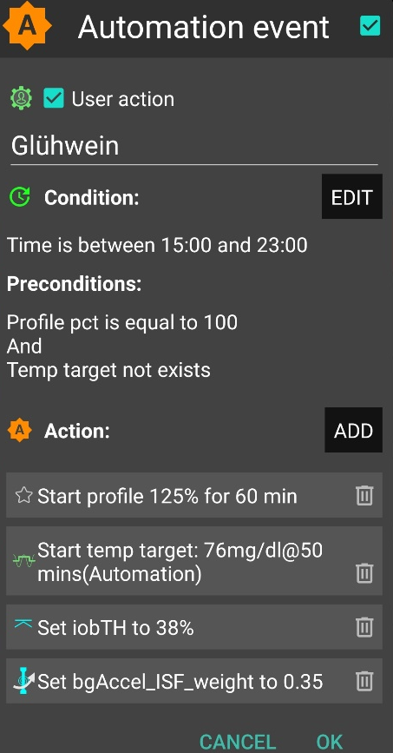
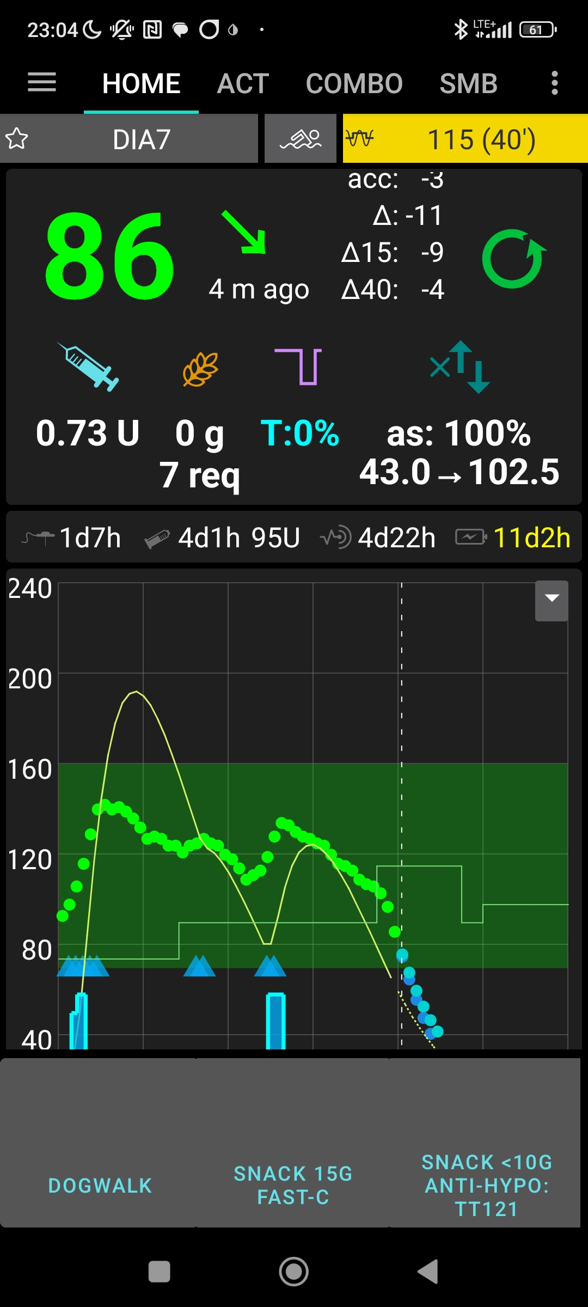
„User action“ is always ticked-on

This will, in the defined time space ..

..offer the “DIY cockpit” button..

..which I must press any time (~90…30 minutes) before my snack.

Note: Make sure that iobTH and bgAccel_ISF_weight revert to default afterwards
Snack 15g fast-C

So, this can be a little extra “project” when setting up your FCL.
You need to research your snack habits (if any), and over time find out which settings in the snack-related Automations work well.

In everyday life you then just must press the related button in your cockpit (which is not time critical at all, except it should be clicked latest a couple of minutes after you took the drink or snack).

If you consume more, and also eat something with your sweet drink, this will more resemble a full meal… however, with unusual amounts of fast carbs.

Note: Pressing your snack button a second time would not help because the lowered iobTH does not allow iob going high enough. So you are better off just letting your normal FCL meal routine run, after your snack mode expired.

Other options when snacks keep extending would require a manual modulation regarding %profile and/or bgAccel_ISF, but keeping the full default set iobTH_percent, or even elevating it (refer to section 5.2.3). If that happens often, define for yourself an extra User action Automation for a bigger snack (= another grey DIY cockpit button).

Caution: If (as in autoISF 3.0) setting a different iobTH or bgAccel_ISF_weight can not be done temporarily (i.e. with a duration attached) you must define a suitable additional Automation, that
must be active in tandem, that restores the default set iobTH or bgAccel-ISF_weight again. Else, once your Automation set in, it will forever shift this important parameter setting!
If for instance you have several Automations that, in combination with a set elevated TT also set a lower iobTH: Don’t be fooled, the duration only applies to the TT. You need an extra Automation for all of them.
I picked out the highest of the altered iobTH values that these Automations can set (45_percent), and then I can automatically restore my default desired 60% via this one Automation (see screenshot - - > )

Installing the DIY cockpit button
In the related Automation, just keep the “User action” box clicked at all times, and define in the Conditions when you want to see that button available for cockpit use (see screenshot above) => you will see that button offered.

Besides snacks, also any other recurring special situations can be addressed via a DIY cockpit button, and receive different aggressiveness up to a suitable iobTH level.

Over time you can have a big number of User action Automations, and keep them “shelved” rather invisibly (clicked in-active, top left box) in your long list of potential Automations. Even when active, they only show in your cockpit (bottom grey field of your AAPS home screen) in the time slot you assigned as potentially relevant.

In the future you might be able to set the stage for a snack and other “disturbances” also via an extended menue behind the TT button on the AAPS home screen, see section 5.3.3.1

Discussion
In case you do have a snack habit and
- can not find settings, as in section 4. defined for your meals, also suit your snacks
- can not pin a as in section 5.1.4
you minimum need a “snack announcement” for which the extra button in your DIY cockpit provides a time-uncritical 1-button-push solution.
This could be a good solution for kids in kindergarten, too. Make sure caregivers understand to use it only once for one snack. Continued snacking would require iob as for a meals. This is what the FCL loop takes care of automatically, - while using the snack button several times in a row would limit iobTH at a too-low level!
In a software update, we might try to automatically block usage of that type of Automation for 2 hours, after it was once used.

5.2.3 Temporarily exiting the FCL

The “last resort” alternative always is to temporarily leave the FCL mode, and handle any disturbance “the traditional way” in hybrid closed loop. For this, we switch the automatic aggressive adaptations of ISF to the bg curve off that are only needed in FCL ….
(if in hybrid closed loop you like e.g. the dura_ISF adapation still, you alternatively could elect to just set bgAccel_ISF_weight temp. to zero, instead)
… and now around meal starts giving a bolus will be necessary.

The suggested improved FCL cockpit user interface with an extra version of violet loop on the AAPS home screen (section 5.3.1 ) would facilitate this transition FCL < - > HCL, including automatic removal and re-appearance of the insulin button at the bottom of the APS home screen.

In case this feature is not yet available, you must:
Exit the FCL mode by going to AAPS/preferences/put in your password/OpenAPS SMB/scrolldown to autoISF settings and switch “Enable ISF adaptation..” OFF
(or, alternatively, set bgAccel_ISF_weight to zero).

Caution: Unfortunately, there is no way yet for your full closed loop with ISF adaptations to come automatically back on, after a selected time for instance. So do not forget to switch your autoISF fully back on, later.

As this will often be forgotten, it may be worth doing a “User action” Automation, for a “temp. FCL OFF” grey button (see section 5.2.2.3).
Caution though, there is very limited experience with this brand new feature. Make sure your Automation definition really applies a duration (or other condition) that will automatically terminate all non-default settings it made. As we have seen e.g. in section 5.1.4, this is not always the case.

To recognize whether autoISF currently runs with ISF adaptation or not, you must consult the profile_sens -> actual_sens indicator below the Autosens%. However, this gets also modified by %profile switches or TT +/- exercise mode. So it is not as easy as it would be with the “violet loop” proposal mentioned already above.
Ultimately, you can of course study the SMB tab to find out what is going on.

5.3 Modulating aggressiveness manually from the improved FCL-cockpit

autoISF 3.0 is an early dev variant of AAPS, and as user you are participating in an on-going development. Of note, autoISF 3.0 is first launched without many of the cockpit features that are presented below in this font color.

Only what is written in black is at this point of some relevance for using autoISF 3.0. No need to read any of the green lines, unless you are interested in contributing to define/design/program further improvements.
This is also an open invitation for you to contact us in case you could help program a module for one of the suggested user interface extras.
For future integration into AAPS Master, an eye should be kept also on the question which other modes (like FCL using Automations and others mentioned in section 13; and maybe also HCL) might benefit from some of the extra features.
For the time being, multi-step work-arounds may become necessary
- In many cases, going into AAPS Preferences and changing settings would be needed (…plus not forgetting to change these settings back, afterwards).
- Automations allow a DIY FCL cockpit, see section 5.2 and case studies 5.2 and 6.2

Keep in mind, though, that the goal should be to interfere with the loop as little as possible. Under the described conditions it can run fully automatically without any user interaction ( = after the initial tuning phase, and related settings made in AAPS /preferences/SMB/autoISF. See section 4. and 5,1).

However, just like in the airplane cockpit: Cruising in full auto mode should involve having an eye on the instruments, and on potential disturbances ahead in the environment.
E.g.: storm ahead => instruct your plane to climb to another flight height.
Anology: exercise ahead => setting an exercise TT, or => pressing a button that activates a sequence of instructions (some of them probably hinging on conditions, like actual iob) how to manage through that exercise situation).

So, for the occasional „disturbance“ coming up, you should find an easy way to
- call up a pre-programmed routine for automatic management, with auto-adjusted aggressiveness, or:
- tweak a setting or two, to temporily adjust the aggressiveness
- There may also arise a desire to just exit the FCL mode, and be your own captain for mastering a special situation.
All this is facilitated within seconds right from the AAPS home screen’s cockpit features to the extent they are already incorporated, or to the extent you can build alike DIY cockpit features via Automations, as described in section 4.1.3 and case studies 5.2 and 6.2):

- The button that is integrated into the violet FCL icon serves as emergeny off button, to quickly stop FCL, or to at least to immediately stop any more SMBs (…just for a couple of minutes, or for the remaining meal time: pick from the options offered with just one keystroke).
Via the violet FCL icon on your AAPS home screen, you also can access a temp. switch-off button for SMBs (see section that next follows below).

- The three top fields (%profile, exercise, TT) provide access to temp. tuning of core parameters, and/or to some pre-programmed routines.
Taken together with some new indicator fields about your loop state (section 5.4.3 – 5.4.4), and the grey DIY cockpit buttons (section 5.2.2.3) this makes the AAPS home screen your cockpit for Full Closed Looping.

Let us look on each of these cockpit elements in some detail:

5.3.1 Violet FCL icon and underlying buttons

Novices to FCL, or really anyone running into a very special situation, may appreciate that the new closed loop icon on the AAPS home screen in pink (for FCL) has buttons to quickly shut off getting more SMBs (1st row), or to enter other loop modes (second row).

It functions very much as the other ones that you know from HCL already, and in fact you get offered some of the same options (for instance, to switch the (full) closed loop off for 15 minutes for going to take a shower)

Note that in FCL you leave all BG regulation, notably against meal spikes, to the loop. So, try not to disconnect in phases when your FCL must ramp up your iob.
The required insulin would still be supplied after you reconnect. However, without the user pre-bolussing, the delay would be more of an issue in FCL than it had been in HCL.

Just pressing on the FCL icon, a dialogue box comes up:
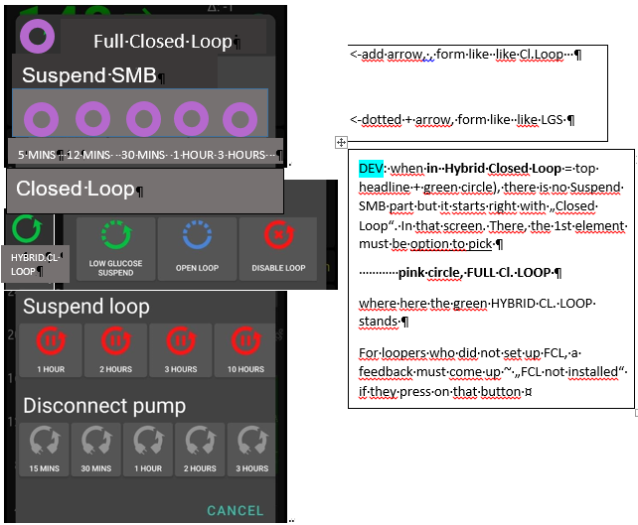
5 MINS 12 MINS 30 MINS 1 HOUR 3 HOURS
Pressing „Suspend SMB“provides fast and easy „emergency braking“ regarding delivery of more SMBs:
Select the one with the desired number of minutes: 5 or 12 for just blocking the potential next SMB(s), and up to 3 hours to manage the entire rest of this meal with %TBR from then on.

Whenever, and why-ever, your FCL is in „no SMBs allowed” mode (e.g. automatically after surpassing an iobTH , or triggered by a set odd TT), the FCL icon will turn into a dotted one.
Instead of remaining duration to end time it indicates in the middle „the condition“, „iob“ or „TT
Add an indication if suspend SMB comes from an Automation, e.g. add an „ (A) „ underneath the #minutes, iob, or TT in the middle of the dotted violet field.
So, as in other (already in HCL existing) cases, those icons show in the middle the minutes left that they will be running, or the condition which would have to go away for this temp. setting to stop.
It always auto-reverts into the FCL state and FCL icon, when time (or other condition) has elapsed.

Pressing „HYBRID CL. LOOP“ or other buttons from the 2nd row provides fast and easy „emergency exit“ into other modes.
This enables beginners an easy „temp. escape“ into their well-known HCL (green) at any point of time. bgAccel_ISF_weight is set to zero when going FCL->HCL. HCL can run with autoISF (for instance dura_ISF) uninhibited otherwise. (check implications for HCL users of autoISF ?? ).
Note: These options from row 2 have no time limit. Loop will not by itself go back to FCL. You see the different loop icon as a reminder to manually revert, when ready.

5.3.2 Buttons „Insulin“, „Calculator“ etc at bottom of AAPS home screen

These buttons are not useful any longer in FCL, and automatically disappear whenever in FCL mode (also in Suspend SMB state), and re-appear when leaving FCL. This applies also when an Automation or technical system failure shut off FCL.
Users who, maybe in the beginning phase, feel better having those buttons, can override the removal (of the insulin button, or any other) by going into /preferences/overview/buttons and forcing them on. They only remain on until the next re-entry into FCL mode, when auto-off happens again.
The reason why we do this: It really is important to let the loop loop, and not interfere more than absolutely needed. Any bolus the user gives will sure distort the bg curve, on which autoISF, especially when aggressively tuned for FCL, builds a lot of its decisions!

5.3.3. Three top fields (%profile, exercise, TT)

Depending on the variedness of lifestyle, the desired %TIR, and the initial tuning effort put in, the user may want occasionally to „tweek“ the aggressiveness of her/his FCL.

The top 3 fields (grey in default mode, yellow when temp. in mode with changed aggressiveness) serve as quick and easy entry points to make temp. switches (as users will be used to for %profile switches, or for setting an EatingSoonTT in HCL, .. which they still can do in FCL … but more:)

Expert FCL users might need this feature rarely, but probably at least to manage activity after meals: Each require opposite aggressiveness, and the switch has to come in a certain point in time that would be difficult to capture. (More see section 6.4 )

5.3.3.1 TT dialoque field ( Currently not available in the pictured form and function ! )

The TT field (top right of AAPS home screen) is a primary daily interface, and a dialogue field opens when pressing on it 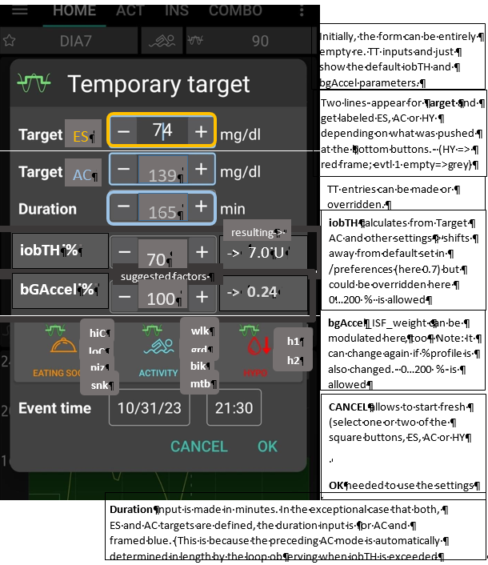

This looks complicated but only because it allows 4 different modes of use. Each user will primarily use her/his preferred one.
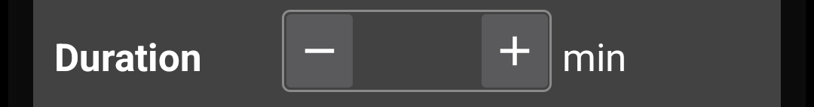
139
165
iobTH %
-> 7.0 U
AC
iobTH calculates from Target AC and other settings-> shifts away from default set in /preferences (here 0.7) but could be overridden here 0…200 % is allowed

TT entries can be made or overridden.
CANCEL allows to start fresh (select one or two of the square buttons, ES, AC or HY

OK needed to use the settings
bgAccel_ISF_weight can be modulated here, too - Note: It can change again if %profile is also changed. 0…200 % is allowed
bGAccel %
-> 0.24
resulting->
suggested factors
70
100
hiC
loC
piz
snk
wlk
grd
bik
mtb
h1
h2
- Who is happy with the initially well tuned FCL and does not have huge variations in daily eating and moving around, will not use the TT at all. FCL is possible without an intervention via the TT button in your cockpit. Actually 4 of 8 modes (GGG …YYY permutations, list see section 5.4.1) are not making use of TT.
- Super easy is also, to just input any odd-TT (odd-numbered temporary target) that will shut out any SMBs for the set duration. That can be a good idea when having a small snack, for instance.
Super quick access to stop SMBs is possible also via the loop icon (section 5.3.1).
Specifically, an EatingSoon TT can be activated here (limited relevance see section 2.5). It is time-un-critical, can be manually set, or come up via an Automation.
The cockpit enables you to set the iobTH differently (override) for the current meal.
Alternatively, iobTH can be temporarily changed in /preferences or using an Automation.

Temp. iobTH will always revert to default when the TT expires. If another TT immediately follows, like in the example of the screen above, it will calculate, (then) show and use a new temp. iobTH.
- The third way is to use the input mask (if already ncluded in your software version see picture above) to freely modulate the loop aggressiveness for a declared number of minutes. Click the bottom big square(s): Either HYPO, or ACTIVITY, or EATING SOON, or ACTIVITY and EATING SOON (example in the pictured screen above). Make or override entries in the offered fields. Press OK.
- The fourth way is to exclusively use one of the 4+4+2 little buttons seen in the bottom part of the TT dialogue box (if already included in your software version). They provide a set of settings (as will immediately show in all input fields above) that the user has set up in Preferences/SMB/autoISF/FullLoop (refer to section 6.3), and can freely label there. For instance „hiC“ at high carb EatingSoon, „piz“ for Pizza/fatty meals, „grd“ for garden work, „mtb“ for mountain biking …
Capturing good settings for not-everyday situations in /preferences (if already included) allows calling them up within 1 second, from your cockpit on the AAPS home screen (…and won’t ruin the FCL experience at all , especially because in most cases it is not time-critical, how long before the intended exercise the buttons are pressed).
Case study 6.2 demonstrates that nearly the same performance and comfort can be reached via the DIY FCL cockpit with the grey extra buttons appearing at the bottom of the AAPS home screen, based on Automations with User action (see also section 5.2.2.3).
The example picture given above, and also case study 6.2, is the most complicated (but also most useful) case, when exercise follows after a sizeable meal. It is then that you need (a) aggressive FCL initial performance at the meal, but, exactly when (!) a (for the intended sport already temp.lowered) iobTH is exceeded, you need (b) to have SMBs automatically switched off and go into the „milder“ mode, as defined for the exercise (with high instead of the immediately prior lowTT, that automatically significantly reduces iobTH again, and insulin sensitivity(resistance) settings too).

Pressing exercise related buttons will automatically also light the exercise button on the main screen yellow.

To summarize, the TT dialogue field offers easy but powerful ad-hoc modulation of loop aggressiveness for FCL (if already included).

5.3.3.2 Exercise button (see more in section 6.)

The exercise button automatically lights yellow when exercise related TTs are activated in the TT dialogue box.
4 of 8 principal FCL modes (section 5.4.1) are making use of the exercise button.

If pressing on the exercise button, a dialogue box appears (if extended design for FCL cockpit is already launched) with info on exercise setting first (and opportunity to override), plus below the activity monitor (experimental for auto-tracking of lighter movement during the day, and effects on sensitivity that may have. See section 4.5).

So, first the exercise settings (as set under TT) are there to read. Example :
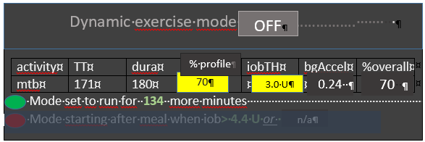
effect.sens.
70 %

The exercise (here mtb) is selected in the dialogue box of the neigboring TT field, and there auto- filled with settings made in the set-up and tuning stage by the user under preferences. They are reported also under the exercise button here, and TT, duration, and % sens (the temp. profile sensitivity that also shows on the %profile field on the left side of the exercise button) can be temp. changed there.
iobTH, bgAccel_ISF and overall resulting effective sensitivity ratio (effect.sens. %) is given in the other fields.
The middle field of the table, „% profile“ either picks up the % set under the %profile button, or an input can be made here, in the exercise button domain, which will:
- turn the neighboring %profile button on yellow and show that inputted % on it, too
- be multiplied with the result from the exercise mode settings per se, and change the % overall, accordingly.
So, if this middle field of above table (dialogue box of sports button) contains a figure other than 100, input field becomes yellow,and you are operating with a combination of traditional PLUS new exercise mode (with all three top buttons of your FCL cockpit yellow). This maximally will soften aggressiveness, for which you get an idea by the last calculated figure.

The mode is either running already (for another number of minutes, as probably also shown in the yellow TT field anyways). Or it is scheduled to run, after insulination for a started meal reaches iobTH (as in table). Or, no exercise is scheduled (both points red, no entries.

The lower part of the exercise dialogue box (not pictured above, but see in section 6.5) is dedicated to the Activity Monitor

5.3.3.3 Profile button
The profile button can still be used to set a different profile, or profile%, for instance to adjust for days with sickness (as you are used to from hybrid closed looping). 4 of 8 modes are not making use of the profile button.

Any inputs made here will be used to modify profile_ISF on which all further changes are made on (multiplied with).

The profile field remains grey if standard profile is applied.
It turns yellow, displaying a %figure relating to any altered loop overall aggressiveness:
- When no inputs (changes from 100% profile) are made here, but inputs in the TT field, e.g. for exercise, automatically lead to different effective sensitivity ratio
- when% is changed by input in the profile button itself, it will be multiplied with with profile_ISF and be used in place of profile_ISF by the algorithm.
However, for exercise (sports) you no longer must make an entry here, because reasonable %reductions should be automatically provided, driven by your set TT (and half-basal exercise target), see section 6.

5.4 Recognizing your loop state in the AAPS home screen

5.4.1 Color scheme of top cockpit buttons tells kind of closed loop that is running

3 Buttons (%profile; exercise; TT) each in 2 states (yellow Y, or grey G) make 2 exp 3 = eight principal FCL modes possible:

GYY = dynamic exercise mode
YGY = not-dynamic „traditional“ exercise mode (if <100%) or hypo mode (if >100%)
GYG = basic closed loop with Activity Monitor running
(Note: activity monitor on/off set in preferences will not affect the button color in autoISF V.3.0; you may recognize Activity monitor is running by the indicated adaptation of sensitivity despite no TT or temp% are set)
GGG = basic closed loop (FCL or HCL) without any altered sensitivities etc
YGG = basic closed loop but with a „long wave“ sensitivity shift (e.g. sickness)
GGY =temp. target like e.g. EatingSDoonTT is set; or Hypo mode
YYG = closed loop with „long wave“ sensitivity adjustement and Activity Monitor running
YYY = dynamic exercise mode in time with additional „long-waved“ sensitivity shift

5.4.2 Information printed on the top buttons (if extended design for FCL cockpit is already launched)
The yellow TT field shows the currently valid TT (and further duration):
(profile) stands for the abbreviation you labeled your selected running profile
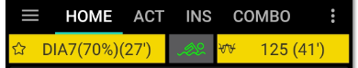
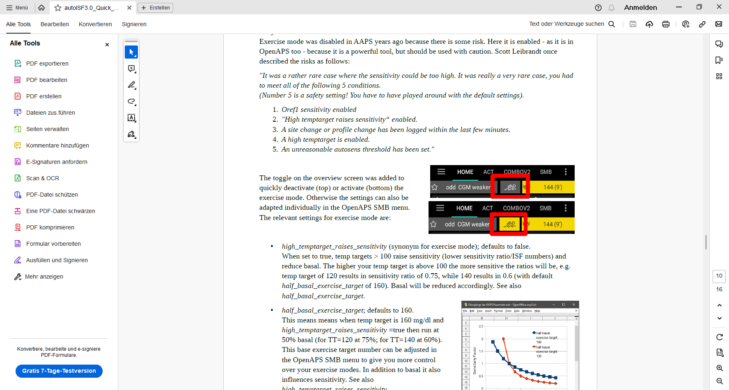
(profile)
In the special case of settings for meal preceding sports, the field will look slightly differently:
…and …
74 (iobTH 139)
(profile)

… when iobTH is first time exceeded, this automatically switches to:
139 ( 2h 45m)
(profile)

Likewise, if on the AAPS main screen just an EatingSoonTT is set (e.g.72), this is entered with the desired duration. Afterwards, it automatically reverts to profile target and the display turns grey again there with e.g. 90 on it (and no time limit).
Without sports context, the middle field remains grey.
72 ( 1h 10m)
(profile))

Independently from setting a TT, the user can choose to set a %profile in the left top field, for an independent number of minutes, e.g. 70% in this screen example: Also, or additionally, this will influence the resulting ISF and sensitivity%

(profile))

The % might change and turn yellow also in context of making TT inputs in the related dialogue box (see chapter TT dialogue field, above). Still, the % (or the length of time the profile switch shall be active) can be independently overriden in the top left field, if so desired.

If an Automation sets a %profile, and/or a TT (e.g. automatic detection of meal start at condition e.g. when delta >10) , this would automatically show in respective field(s) turning yellow and showing the temp. setting. To show the set parameter comes from an Automation, „ (A) „ is added in the end of button text.
Note that an Automation is usually/ always (?) only permitted to temp. change default profile settings, not other pre-existing temp. settings. This is for a good reason : Why should a sometimes in the past thought-out Automation supersede your - just for the occasion specified – temp.settings that you consciously activated for the day?
Advice: Try to stay away from Automations that also aim at temp. modifying aggressiveness. For the reason just given in above note, they often will not kick in anyways. Generally, it also is no good idea to double up sub-algorithms for tweaking loop behaviours.
Also, as pointed to above twice already:

Try to keep things as simple and clear as possible.

That said, a limited number of Automations can be of help in distinct scenarios (that differ in purpose and in applicable time of day).

A good one could be for night time, when your odd profile TT has SMBs shut off, but your experience after pizza nights tells you that, under certain condition patterns (bg, iob), an SMB or two should be „allowed in“ (see example given in section 5.1.2; used also in case study 4.3 ).
Another good example, if you go usually FCL without any use of the TT button (which would be a meal announcement of sorts), is to define an Automation that, after detecting a meal start, automatically sets a low TT to get maximally aggressive first SMBs (as is the author’s preferred way, mentioned already in section 2.5, used also in case study 4.3 ).

5.4.3 FCL related indicator fields in the AAPS home screen

In extra data fields of the AAPS main screen you can always see (not change) the key „aggressiveness“ parameters your loop currently operates operates with (see also home screen example below):
- how profile sensitivity (ISF) adjusts by the %profile input, by autoISF, and/or a set exerciseTT, resulting in an effective sensitivity (ISF that is used to determine insulinRequired. Details for every loop decision see result/debug section of the SMB tab).
- next to current available iob number is an indication of your valid iobTH (the iob above which no more SMBs will be given)
- The AAPS home screen additionally shows, above the deltas, the current acceleration
Having a look at that can be valueable. For instance, when glucose is relatively low and still falling, a positive (and getting more positive) acceleration indicates that bg will swing back up, rather than crash low. This will give info about necessary snack size, and hence help avoid both, unnecessary calories, and going on a bg roller coaster.

5.4.4 Overall home screen: (The violet FCL button might not yet be launched; bottom buttons can also be manually eliminated via AAPS Preferences/Overview/Buttons)
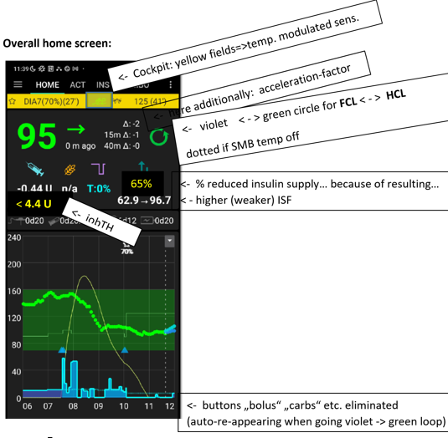
< - Violet < - > green circle for FCL < - > HCL (dotted if SMB off
< - iobTH
(auto- re-appearing when violet –> green loop)
in the middle: minutes counting down if temp.set; below: (A) if coming from an Automation that is running

